**Creating Microservices for Account and Loan  
  
ACCOUNT:  
  
pom.xml**

<project xmlns="http://maven.apache.org/POM/4.0.0"

xmlns:xsi="http://www.w3.org/2001/XMLSchema-instance"

xsi:schemaLocation="http://maven.apache.org/POM/4.0.0 http://maven.apache.org/xsd/maven-4.0.0.xsd">

<modelVersion>4.0.0</modelVersion>

<!-- Inherit Spring Boot defaults -->

<parent>

<groupId>org.springframework.boot</groupId>

<artifactId>spring-boot-starter-parent</artifactId>

<version>3.5.3</version>

</parent>

<groupId>com.cognizant</groupId>

<artifactId>account</artifactId>

<version>0.0.1-SNAPSHOT</version>

<name>Account Microservice</name>

<properties>

<java.version>17</java.version>

</properties>

<dependencies>

<!-- Core web + REST support -->

<dependency>

<groupId>org.springframework.boot</groupId>

<artifactId>spring-boot-starter-web</artifactId>

</dependency>

<!-- Developer tools for auto-restart -->

<dependency>

<groupId>org.springframework.boot</groupId>

<artifactId>spring-boot-devtools</artifactId>

<scope>runtime</scope>

<optional>true</optional>

</dependency>

<!-- For writing unit/integration tests -->

<dependency>

<groupId>org.springframework.boot</groupId>

<artifactId>spring-boot-starter-test</artifactId>

<scope>test</scope>

</dependency>

</dependencies>

<build>

<plugins>

<!-- Enables packaging as executable JAR -->

<plugin>

<groupId>org.springframework.boot</groupId>

<artifactId>spring-boot-maven-plugin</artifactId>

</plugin>

</plugins>

</build>

</project>  
  
  
**AccountApplication.java**  
  
package com.cognizant.Account;

import org.springframework.boot.SpringApplication;

import org.springframework.boot.autoconfigure.SpringBootApplication;

@SpringBootApplication

public class AccountApplication {

public static void main(String[] args) {

SpringApplication.run(AccountApplication.class, args);

}

}

**AccountController.java**

**package** com.cognizant.Account;

**import** org.springframework.web.bind.annotation.*;

@RestController

@RequestMapping("/accounts")

**public** **class** AccountController {

@GetMapping("/{number}")

**public** Account getAccountDetails(@PathVariable String number) {

**return** **new** Account(number, "savings", 6483789);

}

}

**class** Account {

**private** String number;

**private** String type;

**private** **double** balance;

**public** Account(String number, String type, **double** balance) {

**this**.number = number;

**this**.type = type;

**this**.balance = balance;

}

**public** String getNumber()

{

**return** number;

}

**public** String getType()

{

**return** type;

}

**public** **double** getBalance() {

**return** balance;

}

}

**OUTPUT:  
  
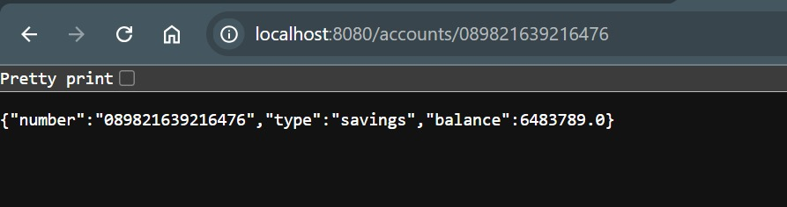**

**LOAN:**

**pom.xml**

<project xmlns="http://maven.apache.org/POM/4.0.0"

xmlns:xsi="http://www.w3.org/2001/XMLSchema-instance"

xsi:schemaLocation="http://maven.apache.org/POM/4.0.0 http://maven.apache.org/xsd/maven-4.0.0.xsd">

<modelVersion>4.0.0</modelVersion>

<!-- Inherit Spring Boot defaults -->

<parent>

<groupId>org.springframework.boot</groupId>

<artifactId>spring-boot-starter-parent</artifactId>

<version>3.5.3</version>

</parent>

<groupId>Loan</groupId>

<artifactId>Loan</artifactId>

<version>0.0.1-SNAPSHOT</version>

<name>Loan Microservice</name>

<properties>

<java.version>17</java.version>

</properties>

<dependencies>

<!-- Core web + REST support -->

<dependency>

<groupId>org.springframework.boot</groupId>

<artifactId>spring-boot-starter-web</artifactId>

</dependency>

<!-- Developer tools for auto-restart -->

<dependency>

<groupId>org.springframework.boot</groupId>

<artifactId>spring-boot-devtools</artifactId>

<scope>runtime</scope>

<optional>true</optional>

</dependency>

<!-- For writing unit/integration tests -->

<dependency>

<groupId>org.springframework.boot</groupId>

<artifactId>spring-boot-starter-test</artifactId>

<scope>test</scope>

</dependency>

</dependencies>

<build>

<plugins>

<!-- Enables packaging as executable JAR -->

<plugin>

<groupId>org.springframework.boot</groupId>

<artifactId>spring-boot-maven-plugin</artifactId>

</plugin>

</plugins>

</build>

</project>

**LoanApplication.java**

package com.cognizant.Loan;

import org.springframework.boot.SpringApplication;

import org.springframework.boot.autoconfigure.SpringBootApplication;

@SpringBootApplication

public class LoanApplication {

public static void main(String[] args) {

SpringApplication.run(LoanApplication.class, args);

}

}

**LoanController.java**

**package** com.cognizant.Loan;

**import** org.springframework.web.bind.annotation.*;

@RestController

@RequestMapping("/loans")

**public** **class** LoanController {

@GetMapping("/{number}")

**public** Loan getLoanDetails(@PathVariable String number) {

**return** **new** Loan(number, "car", 400000, 3258, 18);

}

}

**class** Loan {

**private** String number;

**private** String type;

**private** **double** loan;

**private** **int** emi;

**private** **int** tenure;

**public** Loan(String number, String type, **double** loan, **int** emi, **int** tenure) {

**this**.number = number;

**this**.type = type;

**this**.loan = loan;

**this**.emi = emi;

**this**.tenure = tenure;

}

// Getters

**public** String getNumber()

{

**return** number;

}

**public** String getType() {

**return** type;

}

**public** **double** getLoan()

{

**return** loan;

}

**public** **int** getEmi() {

**return** emi;

}

**public** **int** getTenure() {

**return** tenure;

}

}

OUTPUT:

